FACT SHEET ON ECLASP

The eClasp or e-Inclusion Corporate Sponsorship Programme was introduced to encourage stronger partnership with the industry to create an e-inclusive society and spur e-lifestyle adoption in Singapore. Through eClasp, organisations can help demonstrate the clear and sustainable benefits of an e-lifestyle to Singaporeans by putting Infocomm products and services into their hands.

Who will benefit from eClasp?
Workers, homemakers, senior citizens, students, needy families, self-help groups and volunteer welfare groups.

How can your organisation participate in eClasp?
We welcome sponsorship in cash or kind (e.g. hardware, software, computer peripherals or Internet, broadband and mobile services subscription) in any of the following e-lifestyle programmes:

- Neu PC Programme
- Broadband Demand Growth Programme
- National IT Literacy Programme
- Consumer Trust Programme
- Infocomm Xpress (a travelling tool to promote benefits of an e-lifestyle)
- Infocomm Xperience (Science Centre exhibit)
- e-Celebrations 2003 (for public education and events)

How will sponsors be acknowledged?
Your sponsorship quantum will be accumulated throughout the campaign and consolidated after the last campaign event. In return, your organisation will be recognised at one of these three levels:

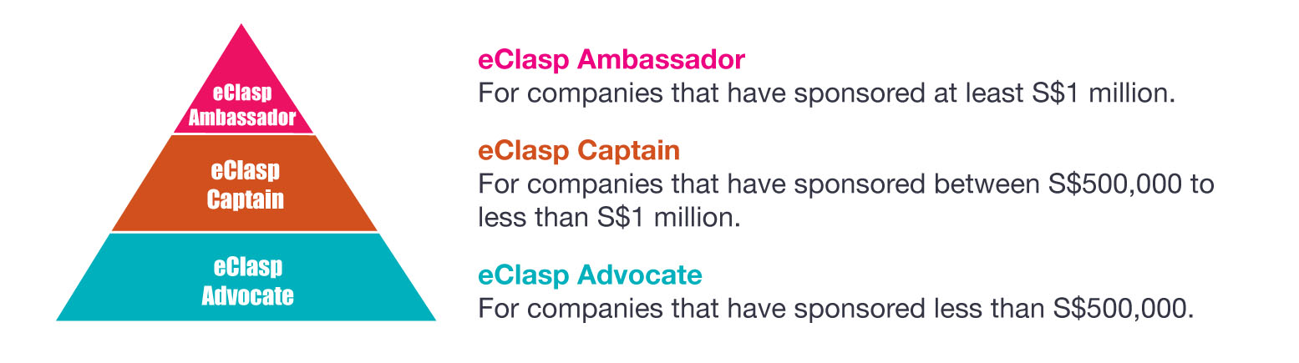
Sponsors will be acknowledged on the campaign website and relevant print and broadcast channels. An appreciation ceremony will be held at the end of the campaign and sponsors will be presented with a token of appreciation for their contribution.

How can my organisation get more information about eClasp?
Please contact Ms Tan Sook Lih of IDA’s e-Lifestyle & Marketing Division at
Tel: 6211 0937, email: tan_sook_lih@ida.gov.sg to indicate your interest in eClasp.

Media contact:
CHIA Sher Ling
Corporate Communication
Infocomm Development Authority of Singapore
Tel: 6211-1840
Email: chia_sher_ling@ida.gov.sg

