E-INVOICING CHAIN LEADER PRE-QUALIFICATION FORM
PART A : PROGRAMME / APPLICANT
PROGRAMME: | Local E-Invoicing Acceleration Fund (LEAF) - Chain Leader
COMPANY:
CONTACT PERSON: | <name>, <designation>, <email>, <phone contact>
DATE SUBMITTED: | <date>

PART B : COMPANY BACKGROUND
Sector:

☐ TRADE & CONNECTIVITY (Logistics, Wholesale, Transport)
☐ BUILD (Real Estate, Construction, Security, Environment)
☐ LIFESTYLE (Retail, Food, Hotel)
☐ MODERN SERVICES (ICT & Media, Financial, Professional)
☐ ESSENTIAL DOMESTIC (Healthcare)
☐ MANUFACTURING (Engineering & Electronics, Energy & Chemicals, Marine, Offshore)

Subsector:_______________________

Business Background:
Provide a synopsis of the company’s business, useful information on revenue, staff strength, number of active customers/suppliers, area of influence in the community or industry, affiliations or associations, etc.

Challenges Faced Related to Invoicing:
Provide a description of the invoicing issues faced today, and what you intend to improve through E-Invoicing, etc. Where are your pain-points – accounts payable (supplier related) or accounts receivables (customer related). Give an indication of the anticipated cost savings or improved performance as a result for the project.

Current Solution(s):
Provide an understanding of the current systems/solutions used.

PART C : PROMOTING E-INVOICING
How the company intends to help promote E-Invoicing:
(This will be used to support IMDA’s evaluation)
Provide details on how/what the company will commit to advance the adoption of E-Invoicing in Singapore (e.g. carry out supplier or customer briefings, support IMDA events (e.g. panel speakers), encourage adoption through EDMs, advertorials in journals and publications, earlier settlements for supplier E-Invoices, develop use cases, etc.)

E-Invoicing to be Implemented by (MM/YY):________________

Please turn overleaf for details on IMDA’s support to qualified E-Invoicing Chain Leaders.

PART D: PROGRAMME DETAILS
LOCAL E-INVOICING ACCELERATION FUND (‘LEAF’) FOR CHAIN LEADER

Applicant’s Basic Eligibility Criteria:
To be eligible for grant support, applicant must firstly fulfil the following criteria:
- Be a business entity registered / incorporated in Singapore and be physically present in Singapore.
- May be a SME or non-SME.
- Significant influence or connectivity with other businesses (having invoicing related transactions with at least 500 other businesses – suppliers and/or customers).

Grant Quantum:
The LEAF programme provides grant support to Chain Leaders up to 50% of their qualified implementation costs, capped at $150,000. The final disbursement shall be no later than 31st March 2023.

Programme Conditions:

There are 3 stages in the programme – the form, the grant application, the project:
- Submit this Pre-qualification Form by 1st October 2020. IMDA will respond within 3-5 working days and If shortlisted, will invite the Applicant to proceed with the Grant Application.
- Grant Application must be submitted to IMDA by 31st December 2020.
- Within 4-5 weeks, applicants will be notified of its success, and the project must commence no later than 31st March 2021
- The project will include a pilot involving at least 5 SMEs* getting connected (ability to send or receive Peppol invoices); the Chain Leader is expected to have the participating SMEs sign off Letters of Intent (LOI) with them. Do note that the grant amount only covers the Chain Leader and not the participating SMEs.
- Among the Chain Leader and 5 SMEs, at least one of them must be connected to the network via a different Access Point Provider.
- Chain Leaders must provide 4 quarterly updates on usage and connections with other businesses for a period of one calendar year as well as a final report.

Others:
- The selection, shortlisting or award of Grant Applications is subject to other agency requirements. Notwithstanding the final decision will rest on IMDA.
- Note that this document and its contents thereof do not constitute a formal agreement between IMDA and the Applicant, insofar as the award of the grant is concerned, as is used solely for the purposes of ascertaining the need, interest and commitment of the Applicant. The Grant Application procedure would ensue upon the assessment of this form.

* An SME is defined as having:
  - Group Annual Sales Turnover of not more than S$100 million OR
  - Group Employment Size of not more than 200 workers
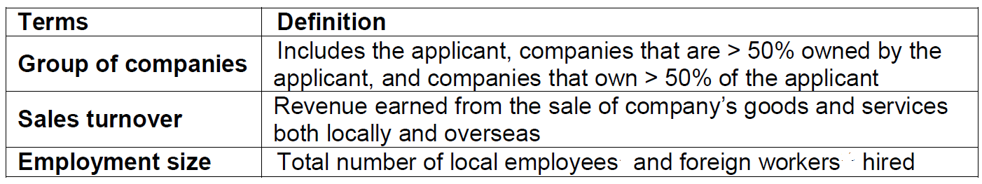

Upon completion of this pre-qualification form, please send it to einvoice@imda.gov.sg.

