Rating Label for GENERAL (G) Films

The classification label comprises the rating marking, and must be affixed to ‘G’ films meant for distribution.

G Marking (downloadable as image files at the IMDA website)
 | Colour:  Pantone 361C  Colour Values:  RGB - R18 G173 B42  CMYK - 80C 2M 100Y  Font:  Myriad Pro Bold |  | Colour:  Pantone Black C  Colour Values:  RGB - R45 G41 B38  CMYK - 63C 62M 59Y 94K  Font:  Myriad Pro Bold

SELF-PRINT RATING LABEL SAMPLE
Under ‘Print’ > ‘Printer Properties’ > ‘Basic’ settings, set ‘Zoom’ to ‘Manual’ & ‘100%’ instead of ‘Auto’, to ensure your printout is close to actual size.

Label Dimensions
Width – 2.00 cm
Height – 1.30 cm

For details on the affixing of classification labels, you may refer to the ‘Films (Classification And Licensing) (Amendments) Regulations 2021' on the IMDA website.

Rating Label for PARENTAL GUIDANCE (PG) Films

The classification label comprises the rating marking, and must be affixed to ‘PG’ films meant for distribution.

PG Marking (downloadable as image files at the IMDA website)
 | Colour:  Pantone 361C  Colour Values:  RGB - R18 G173 B42  CMYK - 80C 2M 100Y  Font:  Myriad Pro Bold | 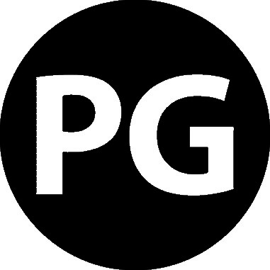 | Colour:  Pantone Black C  Colour Values:  RGB - R45 G41 B38  CMYK - 63C 62M 59Y 94K  Font:  Myriad Pro Bold

SELF-PRINT RATING LABEL SAMPLE
Under ‘Print’ > ‘Printer Properties’ > ‘Basic’ settings, set ‘Zoom’ to ‘Manual’ & ‘100%’ instead of ‘Auto’, to ensure your printout is close to actual size.

Label Dimensions
Width – 2.00 cm
Height – 1.30 cm

For details on the affixing of classification labels, you may refer to the ‘Films (Classification And Licensing) (Amendments) Regulations 2021' on the IMDA website.

Rating Label for PARENTAL GUIDANCE 13 (PG13) Films

The classification label comprises the rating marking, and must be affixed to ‘PG13’ films meant for distribution.

PG13 Marking (downloadable as image files at the IMDA website)
 | Colour:  Pantone 361C  Colour Values:  RGB - R18 G173 B42  CMYK - 80C 2M 100Y  Font:  Myriad Pro Bold | 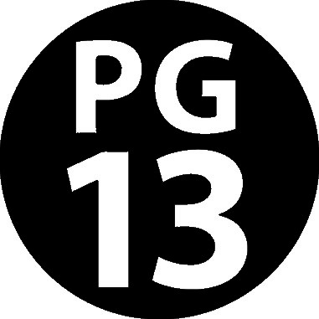 | Colour:  Pantone Black C  Colour Values:  RGB - R45 G41 B38  CMYK - 63C 62M 59Y 94K  Font:  Myriad Pro Bold

SELF-PRINT RATING LABEL SAMPLE
Under ‘Print’ > ‘Printer Properties’ > ‘Basic’ settings, set ‘Zoom’ to ‘Manual’ & ‘100%’ instead of ‘Auto’, to ensure your printout is close to actual size.

Label Dimensions
Width – 2.00 cm
Height – 1.30 cm

For details on the affixing of classification labels, you may refer to the ‘Films (Classification And Licensing) (Amendments) Regulations 2021' on the IMDA website.

Rating Label for NO CHILDREN UNDER 16 (NC16) Films

The classification label comprises the rating marking, and must be affixed to ‘NC16’ films meant for distribution.

NC16 Marking (downloadable as image files at the IMDA website)
 | Colour:  Pantone 1655C  Colour Values:  RGB – R255 G90 B0  CMYK - 79M 100Y  Font:  Myriad Pro Bold | 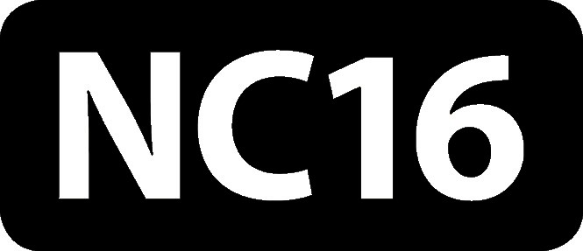 | Colour:  Pantone Black C  Colour Values:  RGB - R45 G41 B38  CMYK - 63C 62M 59Y 94K  Font:  Myriad Pro Bold

SELF-PRINT RATING LABEL SAMPLE
Under ‘Print’ > ‘Printer Properties’ > ‘Basic’ settings, set ‘Zoom’ to ‘Manual’ & ‘100%’ instead of ‘Auto’, to ensure your printout is close to actual size.

Label Dimensions
Width – 2.00 cm
Height – 1.30 cm

For details on the affixing of classification labels, you may refer to the ‘Films (Classification And Licensing) (Amendments) Regulations 2021' on the IMDA website.

Rating Label for MATURE 18 (M18) Films

The classification label comprises the rating marking, and must be affixed to ‘M18’ films meant for distribution.

M18 Marking (downloadable as image files at the IMDA website)
 | Colour:  Pantone 1655C  Colour Values:  RGB – R255 G90 B0  CMYK - 79M 100Y  Font:  Myriad Pro Bold | 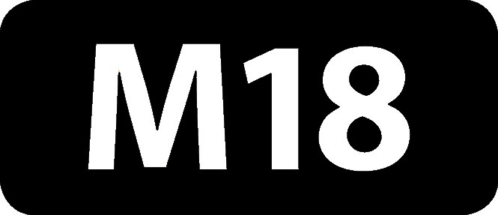 | Colour:  Pantone Black C  Colour Values:  RGB - R45 G41 B38  CMYK - 63C 62M 59Y 94K  Font:  Myriad Pro Bold

SELF-PRINT RATING LABEL SAMPLE
Under ‘Print’ > ‘Printer Properties’ > ‘Basic’ settings, set ‘Zoom’ to ‘Manual’ & ‘100%’ instead of ‘Auto’, to ensure your printout is close to actual size.

Label Dimensions
Width – 2.00 cm
Height – 1.30 cm

For details on the affixing of classification labels, you may refer to the ‘Films (Classification And Licensing) (Amendments) Regulations 2021' on the IMDA website.

Rating Label for RESTRICTED 21 (R21) Films

The classification label comprises the rating marking, and must be affixed to ‘R21’ films meant for distribution*.

R21 Marking (downloadable as image files at the IMDA website)
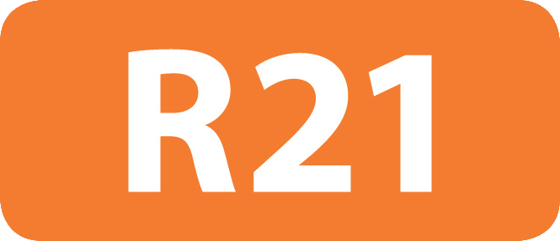 | Colour:  Pantone 1655C  Colour Values:  RGB – R255 G90 B0  CMYK - 79M 100Y  Font:  Myriad Pro Bold | 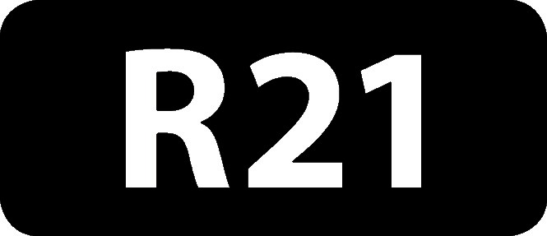 | Colour:  Pantone Black C  Colour Values:  RGB - R45 G41 B38  CMYK - 63C 62M 59Y 94K  Font:  Myriad Pro Bold

SELF-PRINT RATING LABEL SAMPLE
Under ‘Print’ > ‘Printer Properties’ > ‘Basic’ settings, set ‘Zoom’ to ‘Manual’ & ‘100%’ instead of ‘Auto’, to ensure your printout is close to actual size.

Label Dimensions
Width – 2.00 cm
Height – 1.30 cm

For details on the affixing of classification labels, you may refer to the ‘Films (Classification And Licensing) (Amendments) Regulations 2021' on the IMDA website.

*Video distribution is allowed up to M18

